**Packet Tracer – Skills Integration Challenge 6.6.1.2**

1. **Topology**

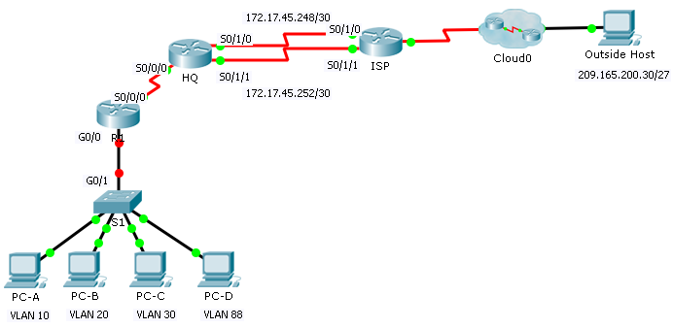

**Addressing Table**

| **Device** | **Interface** | **IP Address** | **Subnet Mask** | **Default Gateway** | **VLAN** |
| --- | --- | --- | --- | --- | --- |
| R1 | S0/0/0 | 172.31.1.2 | 255.255.255.0 | N/A | N/A |
| G0/0.10 | 172.31.10.1 | 255.255.255.0 | N/A | 10 |
| G0/0.20 | 172.31.20.1 | 255.255.255.0 | N/A | 20 |
| G0/0.30 | 172.31.30.1 | 255.255.255.0 | N/A | 30 |
| G0/0.88 | 172.31.88.1 | 255.255.255.0 | N/A | 88 |
| G0/0.99 | 172.31.99.1 | 255.255.255.0 | N/A | 99 |
| S1 | VLAN 88 | 172.31.88.33 | 255.255.255.0 | 172.31.88.1 | 88 |
| PC-A | NIC | 172.31.10.21 | 255.255.255.0 | 172.31.10.1 | 10 |
| PC-B | NIC | 172.31.20.22 | 255.255.255.0 | 172.31.20.1 | 20 |
| PC-C | NIC | 172.31.30.23 | 255.255.255.0 | 172.31.30.1 | 30 |
| PC-D | NIC | 172.31.88.24 | 255.255.255.0 | 172.31.88.1 | 88 |

1. **VLAN Table**

| **VLAN** | **Name** | **Interfaces** |
| --- | --- | --- |
| 10 | Sales | F0/11-15 |
| 20 | Production | F0/16-20 |
| 30 | Marketing | F0/5-10 |
| 88 | Management | F0/21-24 |
| 99 | Native | G0/1 |

1. **Scenario**

In this activity, you will demonstrate and reinforce your ability to configure routers for inter-VLAN communication and configure static routes to reach destinations outside of your network. Among the skills you will demonstrate are configuring inter-VLAN routing, static and default routes.

1. **Requirements**

* Configure inter-VLAN routing on **R1** based on the **Addressing Table**.
* Configure trunking on **S1**.
* Configure four directly attached static route on **HQ** to each VLANs 10, 20, 30 and 88.
* Configure directly attached static routes on **HQ** to reach **Outside Host**.
  1. Configure the primary path through the Serial 0/1/0 interface.
  2. Configure the backup route through the Serial 0/1/1 interface with a 10 AD.
* Configure directly attached primary and backup summary routes on **ISP** for the entire 172.31.0.0/17 address space.
  1. Configure the primary path through the Serial 0/1/1 interface.
  2. Configure the backup route through the Serial 0/1/0 interface with 25 AD.
* Configure a directly attached default route on **R1**.
* Verify connectivity by making sure all the PCs can ping **Outside Host**.

Answer Scripts

!R1!!!!!!!!!!!!!!!!!!!

en

config t

interface GigabitEthernet0/0

no shutdown

!

interface GigabitEthernet0/0.10

description Sales VLAN

encapsulation dot1Q 10

ip address 172.31.10.1 255.255.255.0

!

interface GigabitEthernet0/0.20

description Production VLAN

encapsulation dot1Q 20

ip address 172.31.20.1 255.255.255.0

!

interface GigabitEthernet0/0.30

description Marketing VLAN

encapsulation dot1Q 30

ip address 172.31.30.1 255.255.255.0

!

interface GigabitEthernet0/0.88

description Management VLAN

encapsulation dot1Q 88

ip address 172.31.88.1 255.255.255.0

!

interface GigabitEthernet0/0.99

description Native VLAN

encapsulation dot1Q 99 native

ip address 172.31.99.1 255.255.255.0

!

ip route 0.0.0.0 0.0.0.0 Serial0/0/0

!

end

!S1!!!!!!!!!!!!!!!!!!!!!!!!!!

en

config t

int g0/1

switchport mode trunk

switchport trunk native vlan 99

end

wr

!HQ!!!!!!!!!!!!!!!!!!!!!!!!!

en

conf t

ip route 172.31.10.0 255.255.255.0 Serial0/0/0

ip route 172.31.20.0 255.255.255.0 Serial0/0/0

ip route 172.31.30.0 255.255.255.0 Serial0/0/0

ip route 172.31.88.0 255.255.255.0 Serial0/0/0

ip route 209.165.200.0 255.255.255.224 Serial0/1/0

ip route 209.165.200.0 255.255.255.224 Serial0/1/1 10

end

wr

!ISP!!!!!!!!!!!!!!!!!!!!!!!!!

en

conf t

ip route 172.31.0.0 255.255.128.0 Serial0/1/1

ip route 172.31.0.0 255.255.128.0 Serial0/1/0 25

end

wr